VERTRIEBSSTRATEGIE BAUEN

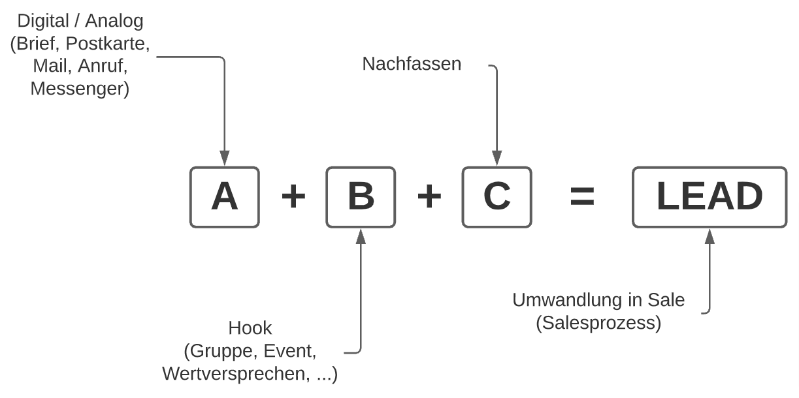

|  |  |  |
| --- | --- | --- |
| **A**  **(digital / analog)** | **B**  **(Hook)** | **C**  **(Nachfassen)** |
| Brief | Gruppe | E-Mail |
| Postkarte | Event | Telefon |
| Messe | Leadmagnet | Brief |
| Haustür | Buch | Messenger |
| Mail | Wertversprechen |  |
| Anruf |  |  |
| Ad |  |  |
| Messenger |  |  |
| SoMe Post |  |  |